**Client Side Importance – Calum**



**Description**

This displayed the name and date of the clients next workout

**Ranking**: 10 / 10

**Comments**: Very important for clients as it will help them to follow coaches orders



**Description**

This displays the clients daily steps for the day against the goal set by the Trainer feeding in from their fitbit

**Ranking**: 8 / 10

**Comments**: Very important for clients that are trying to lose weight or lean out



**Description**

This displays the clients sleep ranking from the night before feeding in from their fitbit

**Ranking**: 5 / 10

**Comments**: Not all clients will use this

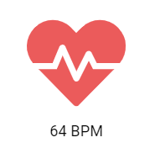

**Description**

This displays the clients live heart rate feeding in from their fitbit

**Ranking**: 5 / 10

**Comments**: No that important as it will be viewed during workout on the fitbit itself

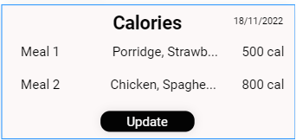

**Description**

This displays the clients current intake for the day, along with the macros of each meal

**Ranking**: 8 / 10

**Comments**: Very good to have this in the one app instead of having to use the likes of MyFitnessPal as well



**Description**

This displays the clients total calories for the day against the goal set for them by the trainer

**Ranking**: 8 / 10

**Comments**: Same as the calorie input section